Our Reference: DRED/HP018/PO DATE: 20th January 2025

To the Occupier

Dear Sir / Madam,

PEDESTRIAN ZEBRA CROSSING MANOR FARM ROAD

Over an extended period of time concerns have been raised regarding pedestrian safety whilst crossing Manor Farm Road, Huyton specifically outside Manor Farm Shops, as there are no pedestrian crossing facilities in this area.
From reviewing the road layout, traffic flow and the number of pedestrians crossing, it is proposed that two zebra crossing facilities sited either end of the shopping parade are the most suitable locations. Please find attached plan 2093-WAT-HGN-103-DR-D-950101-P04 Manor Farm Road, which shows the extent of the proposed works for your information.
A copy of the plan of the exact location of the Zebra Crossing and a statement of the Council’s reasons for making the proposal may also be inspected at.
Knowsley Metropolitan Borough Council Municipal Building, One Stop Shop Archway Road Huyton Merseyside L36 9YU or
www.knowsley.gov.uk/consultations.

The scheme will improve pedestrian accessibility to Sylvester School, St John’s Millenium Green, the shopping parade and the medical centre. Walking can make a very positive contribution to improving health and tackling obesity, improving accessibility, tackling congestion, reducing carbon emissions and improving the local environment.

Your views on the proposals are important to us, therefore I should be grateful if you would provide any formal feedback you have by Mon 10th February 2025. All the information provided will be treated confidentially and will only be utilised by the Council to evaluate the proposals.

Any objection must be in writing, state the grounds on which it is made and be sent to Knowsley Metropolitan Borough Council, Legal Services, 2nd Floor, Municipal Building, Archway Road Huyton Merseyside L36 9YU or by e-mailing Highway.consultations@knowsley.gov.uk.

Yours Faithfully,

Paul O’Reilly

Principal Engineer - Projects and Development.

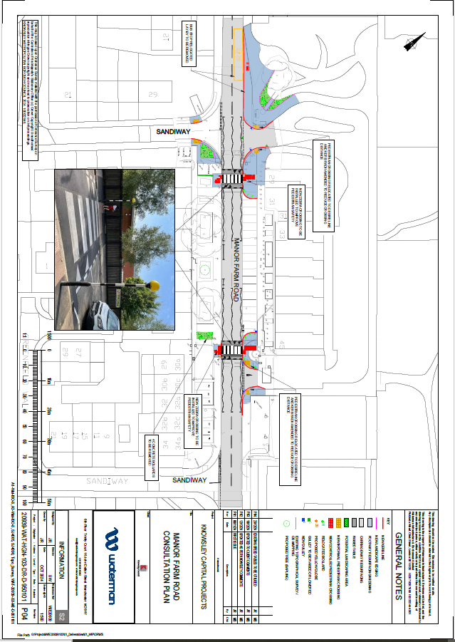

STATEMENT OF REASONS

(MANOR FARM ROAD, HUYTON)

PEDESTRIAN CROSSING (ZEBRA)

Over an extended period of time, concerns have been raised regarding pedestrian safety whilst crossing Manor Farm Road, Huyton specifically outside Manor Farm Shops. Currently, there is no pedestrian crossing facility outside the shops
From reviewing the road layout, traffic flow and the number of pedestrians crossing it is proposed that two Zebra crossing facilities either end of the shops is the most suitable solution and is to be implemented.

The location of the pedestrianised crossing will be at a point approximately 113 metres and 175 metres east of its junction with St Johns Road, this allows for access to the shops on the north side and houses on the south side of Manor Farm Road.

The scheme will improve sustainable choices for travelling to local employment, education, retail, health, and recreation facilities. Walking can make a very positive contribution to improving health and tackling obesity, improving accessibility, tackling congestion, reducing carbon emissions and improving the local environment.

Dated.20th January 2025

