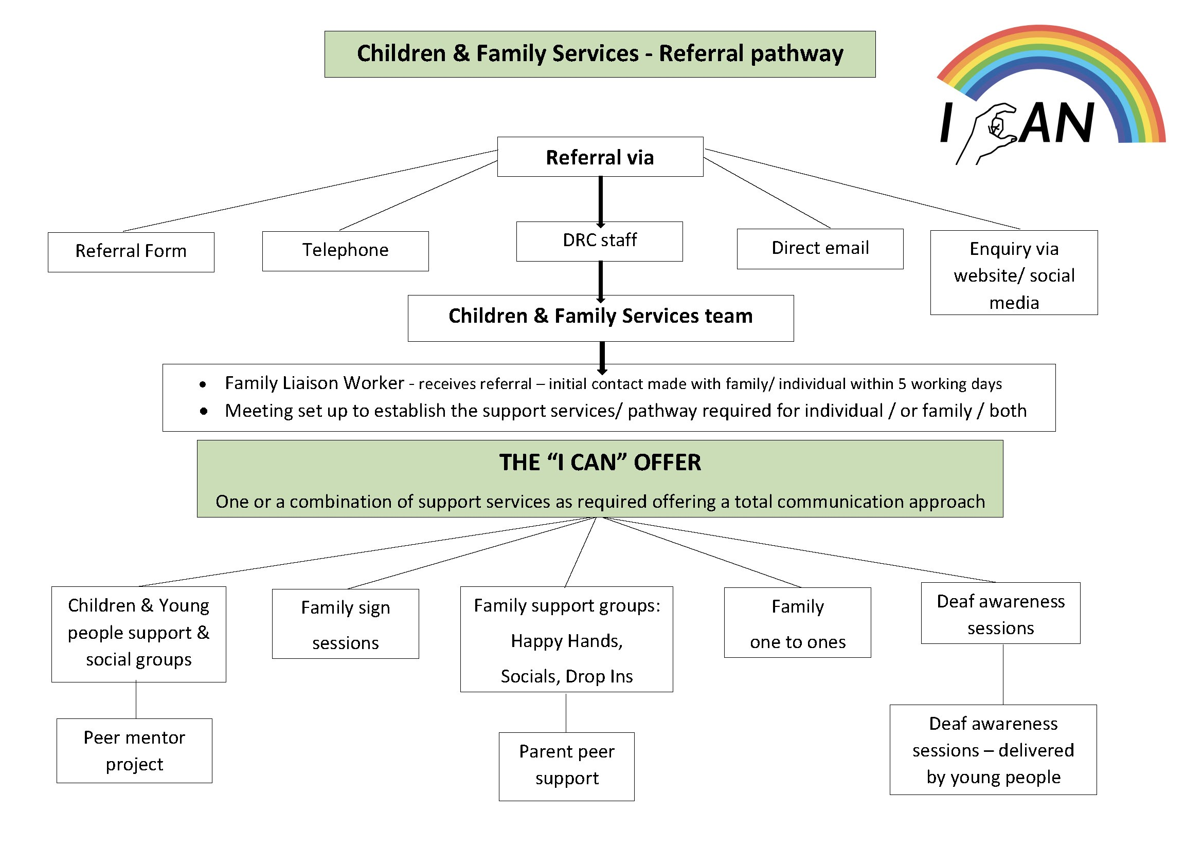

Date of referral |  |  | Young person aware of referral? |  |  |  | Yes/No
Person making referral |  |  |  | Contact Details
Organisation |  |  | Email
Reason for Referral

Young Person Details
Name |  |  | DOB
Address
 |  | Postcode

Parent/Carer Details
Parent/Carer 1 |  | Home
Email |  | Mobile
Address
Parent/Carer 2 |  | Home
Email |  | Mobile
Address

Sensory Information
Deaf |  | Hard of hearing |  |  |  | Hearing |  |  | Deafblind
Communication preference
BSL user |  |  |  | SSE user |  |  |  | Lip reader
English |  |  |  | Other
Assistive Technology
Hearing Aid |  |  |  | Cochlear Implant |  |  |  | Bone Conduction
Middle Ear Implant |  |  |  | Auditory Brainstem Implant |  |  |  | None
Other
Additional Information

Would like further information about… (please tick all that apply)
Family Groups (including: Happy Hands, social groups, peer support for adults, family activities) |  | Family Sign language |  | Equipment |  | Advocacy
Youth Groups |  | Deaf Awareness |  | Volunteering |  | Other
I CAN project (support for children, young people and families) |  | Peer mentor/ buddy support (for children and young people) |  | Fundraising support

OFFICE USE ONLY |  | Date Received |  |  |  | Method
Referred to |  |  | Contact with family made |  | Yes/No |  |  | Date
Please return the completed from to ICAN@deafnessresourcecentre.org or mail to: Children, Young people and family Deafness Resource Centre, 32-40 Dentons Green Lane, St Helens, WA10 2QB
Medical Information
Does your child have any known medical conditions or disabilities?
Does your child have any know allergies?
Last tetanus injection
Doctor name |  | Phone Number
Doctors Address |  |  | Postcode
Does your child require additional support; either as a result of disability or through individual circumstances or preferences? Please let us know so that we can better plan for everyone to take part.

Education Information
Nursery Name
School Name |  |  |  | Year of start
In what year will your child enter |  | High School |  | College

Emergency Phone Numbers
Please list suitable contacts if you are unavailable in case of an emergency
Name |  | Phone |  | Relationship
Name |  | Phone |  | Relationship
Name |  | Phone |  | Relationship
Name |  | Phone |  | Relationship

Consent (Complete appropriate)
In the event that reasonable attempts to contact me at one of the numbers provided have been unsuccessful, I hereby give my consent for:
- The administration of any treatment deemed necessary by a doctor or dentist
- The transfer of my child to hospital
Name |  | Signed |  | Date
I do not give my consent for emergency medical treatment of my child. In the event of any illness or injury requiring treatment, I wish DRC to take no action or to:

Name |  | Signed |  | Date

Photo / Video Permission Form

At the DRC we would like to take photographs/videos of the group which could include yourself and/or your child(ren).

We may wish to include these photographs/videos in future promotional material such as leaflets, Facebook pages, websites etc.

Could you please indicate if we have permission to use yours and/or you child’s photographs/videos and where we may do so by completing the information below?

Thank you.

Consent

Please tick the appropriate boxes below

 | YES | NO
Deafness Resource Centre Website
Deafness Resource Centre Facebook – Public Page
Deafness Resource Centre Twitter
Deafness Resource Centre Instagram
Happy Hands Facebook – Closed Group
Happy Hands Facebook – Public Page
Happy Hands Twitter
Happy Hands Website
Deaf Active Facebook – Closed Group
Promotional Material
Newsletters
Other organisations (e.g. NDCS, Children in Need, Signature)

Name: _______________________________________________
(If appropriate)
Name of Child (1) ______________________________________
Name of Child (2) ______________________________________
Name of Child (3) ______________________________________
Relationship to child (if appropriate): _______________________
Signature: ____________________________________________
Date: ________________________________________________

CUSTOMER PRIVACY NOTICE
Here at the Deafness Resource Centre we take your privacy seriously and will only use your personal information to administer your account and to provide the products and services you have requested from us.
The DRC will never share your personal data with third-parties without your consent. Your data will be stored and disposed of securely and only used for the purposes stated above.
If you agree to your personal data being processed as outlined above please sign below to confirm consent. You have a right to access your personal data at any time and consent to process the data can be withdrawn.
Failure to provide personal data may result in the DRC being unable to provide services or enter into an agreement with you.
From time to time we would like to contact you with details of other [products]/ [offers]/[services]/[competitions] we provide. If you consent to us contacting you for this purpose please tick to say how you would like us to contact you:
Post ☐ Email ☐ Telephone ☐ Text message ☐

Signed:……………………………………………….
PRINT name:
Date:

Deafness Resource Centre Ltd
32-40 Dentons Green Lane
St Helens WA10 2QB

Data Protection Lead – Chief Officer
Contact details: telephone 01744 23887
Email: helen.fitzgerald@deafnessresourcecentre.org
Further guidance: ICO.org.uk

