

KNOWSLEY METROPOLITAN BOROUGH COUNCIL

STREET NAMING AND NUMBERING GUIDANCE

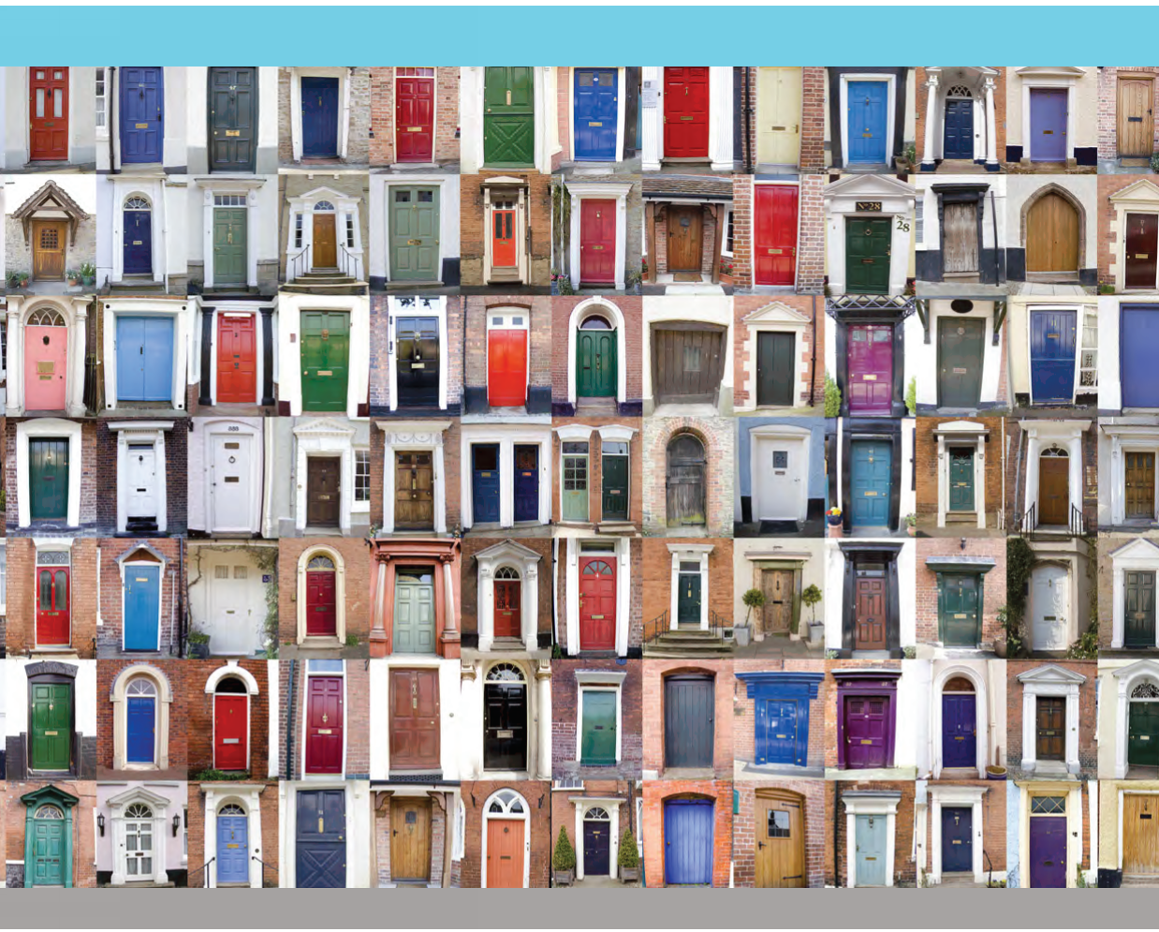

February 2014

1. INTRODUCTION
Knowsley Metropolitan Borough Council, as the street naming and numbering authority, uses its powers under Sections 64 and 65 of the Town Improvement Clauses Act 1847 and Sections 17 – 19 of the Public Health Act 1925 to control the naming and numbering of streets and buildings. All proposals for new street names and property numbers, or changes to existing ones must, by law, be sent to the Council for compliance checking and approval before use.

The objective of street naming and numbering is to establish a unique, unambiguous and logical address for each property so that it can be easily and quickly located to facilitate:

- Rapid responses by ambulance, fire and police services
- The delivery of post by the Royal Mail and courier services
- Accurate record keeping regarding legal transactions and taxation etc

This guidance document is intended to provide assistance to developers and building occupiers regarding the naming and numbering of streets and buildings. It contains information that is relevant to both new developments and the renaming/renumbering of existing streets and buildings.

To ensure that the process of obtaining postal addresses and postcodes proceeds efficiently, developers are strongly advised to consider proposals for street naming and numbering as soon as possible after obtaining planning permission.

2. STREET NAMING
The Council is responsible for naming new streets within Knowsley, but encourages developers to propose their own preferred street names for consideration, provided they adhere to the conventions within this document. It is however recommended that more than one suggestion for a new name be put forward in case one fails to meet the criteria outlined. Please note that it is desirable that any suggested road name should have some connection with the area or its history. The Council’s decision is final. Except in exceptional circumstances roads/developments should not be named after living persons.

Developers are strongly advised to be very cautious in the use of marketing names for their new developments because if they fail to meet the specified criteria they will not receive the Council’s approval and will therefore not be retained as part of the address. Any literature distributed to prospective purchasers should therefore clearly state that the marketing name may not necessarily form part of the property address.

It is recommended that developers agree names for all proposed streets with the Council prior to the commencement of construction.

Street Naming Criteria:
- All highways, including access ways or cul-de-sacs off main spine roads within estates, must have separate names. Street extensions should have the same name as the original.
- Names must not be identical or sound similar to any existing street or buildings within the local area (5 mile radius including adjoining local authority districts).
- Ideally, names should have a proven relevance to the history or local geological features of the area or they should commemorate past industries or deceased local personalities. Any personality must have made a significant contribution to the community either at a national, regional or local level or have a historical connection to the land being developed. The local library should be able to provide advice regarding the history of an area if you have difficulty choosing an appropriate name.
- Themes may be used for the naming of a network of streets within a development, but they should still have some relevance to the local area.
- So that names can be easily understood over the telephone in the event of an emergency, they should generally have no more than three syllables, they should not be difficult to spell or pronounce and they should not contain any form of punctuation.
- Names that could be construed to be offensive or those that give the impression that the area is in some way unappealing should be avoided.
- The names of current businesses operating in the area shall not be used as this could be construed as a form of advertising.
- In order to avoid causing offence either by inclusion or exclusion, or to appear biased, a street shall not be named after a living or recently deceased person or individual. This is a clear recommendation in the National Data Entry Conventions document (DEC – NLPG) and is considered best practice
- Street names that are open to re-interpretation by graffiti or shortening of the name should be avoided.
- The use of Royal names and titles, including ‘Royal’, requires the approval of the Queen, who acts on the advice of the Home Secretary. It can be a lengthy process to seek permission for a Royal name and this should be carried out by the developer/applicant prior to submitting the suggestion to the Council.
- No street name should start with 'The'.
- Street names must end with one of the following suffixes:

Suffix | Applicable Road Type
Avenue, Drive, Lane, Place, Road or Street | Any road.
Crescent | Crescent shaped road.
End | for a road with only one entrance/exit
Gardens | Any road, provided there is no confusion with any local open space.
Hill | For hill roads only.
Rise | Residential roads with steep gradients.
Chase, Close, Court or Mews | For a hillside road only
Grove | Small road or cul-de-sac.
Green | A courtyard, provided there is no confusion with any local open space.
Square | For a square only.
Terrace | A terrace of houses but NOT as a subsidiary name within another road.
Walk | Pedestrian way only
Way | Any – except culs-de-sac.
View | Only acceptable in appropriate circumstances. Please contact the Council to discuss.
Row | Only acceptable in appropriate circumstances. Please contact the Council to discuss.
Other suffixes will only be considered in exceptional circumstances. Please contact the Council to discuss.
- All suffixes should be given very careful consideration so that they do not give a false impression of the location.
- Some suffixes may also be incorporated in street names that end with another suffix (e.g. Park View Road).
- It is recommended that more than one name is proposed for each street in case the preferred option fails to meet the outlined criteria or is deemed unacceptable by the Council, whose decision, as street naming and numbering authority, is final.
- For the provision and installation of street nameplates developers should contact the Council’s nameplates suppliers whose details are as follows:

Plastic nameplates:
N Sign Ltd
Sign House, Maritime Road, Stockton on Tees, TS18 2EZ
info@n-sign.co.uk
Tel: 01642 800222
Fax: 01642 601521

Metal nameplates:
G&G Signs Ltd
15 foxholes Road, Off Golf Course Lane, Leicester, LE3 1TH
info@ggstreetnameplates.com
Tel: 0116 2544445
Fax: 0116 2542020

3. BUILDING NUMBERING
The address of a property depends on the location of the main external entrance door. The Council will allocate property numbers using the following criteria:

Individual Properties
- Buildings will be numbered according to the street in which the main entrance is located, which may not necessarily be the vehicular access.
- All numbers will be allocated in a logical sequence and no numbers will be excluded.
- For new streets, odd numbers will be allocated to properties on the left hand side of the road (facing away from the town centre) and even numbers to those on the right.
- Dependent upon the layout of the site, small culs-de-sac may be numbered consecutively in a clockwise direction.
- If one or more dwellings are built between two existing ones and there are insufficient numbers available then a sequence of alphabetical suffixes (a, b, c etc) will be added to the number.
In some instances, where properties have a name but no number the Council has powers to create numbering schemes and to enforce the usage of those numbers.
Developers should note that the property numbers allocated by the Council are unlikely to correspond with their site plot numbers. Any literature distributed to prospective purchasers must clearly state that a property’s plot number may not necessarily be the property number that forms part of its official address.

Blocks of Properties

- A property number will be given to each dwelling within blocks of flats or apartments. However, if there are insufficient numbers available because of existing development then the whole block will be given a number and the individual dwellings within will be numbered, not lettered, in a logical sequence.
- If a multi-occupied building has entrances in more than one street, but each entrance leads to a separate occupier, then each entrance will be numbered in the appropriate street.
- A named building will not have more than one number in any one street.

4. BUILDING NAMING

Individual Dwellings or Houses

- In existing streets where there is already a numbering scheme in place, house names may be permitted, but it would be in addition to the existing number and would not replace it. The original number should always be displayed on the property, and quoted within the address on all correspondence.
- In existing un-numbered streets (mainly in rural areas) it is essential that houses are officially allocated names that are registered with the emergency services. The owners of new properties within these streets are normally allowed to choose the property name, but they must consult the Council regarding any proposals. The chosen name should not repeat an existing name in use elsewhere within the same postal area (or be identical or similar to a building or street name elsewhere within the wider area) and the Council will not formally allocate a name as part of an address unless it meets this criteria.

Blocks of Dwellings, Offices, Commercial, Institutional or Leisure

The Council will consider names suggested by developers for their new development blocks, provided they are in accordance with the following conventions:

- No building name should include numbers.
- No building name should start with 'The'.
- All named blocks should end with one of the following suffixes:

Suffix | Applicable Block Type
Apartments, Heights, Mansions or Villas | Residential
Centre | Offices, Commercial, Institutional, Leisure
Hall | Residential, Offices, Leisure
House or Manor | Residential, Offices, Commercial, Institutional
Lodge | Residential or Offices
Point or Tower | High residential or Offices,

Two of the biggest problem areas in naming and numbering are:

- The overwhelming desire of applicants to repeat existing names in new roads or buildings titles such as a request for St. Mary’s Close off an existing St. Mary’s Way, near St. Mary’s Church etc.

- The informal adoption of unofficial “marketing” titles used by developers in the sale of new properties. These will often fall foul of the Council’s policy on a number of counts and occupiers of such premises unfortunately feel aggrieved by the ‘loss’ of a supposedly prestigious address and its replacement with something perhaps a little more mundane.

It is to be remembered that the object of the exercise is to establish a unique, unambiguous and logical address for each property in a locality.

Another aspect of the name selection which is considered in allocating street names, linked again to the emergency services, is selection of names that can easily be understood over the telephone in the event of an emergency (they should be easy to spell and pronounce). The adoption of names having no more than three syllables and, wherever possible little scope for ambiguity in spelling is favoured for this reason.

The guidelines above set out the Council’s criteria for street naming and numbering, variations from the general rule are sometimes allowed but only where it is considered that the ‘public safety’ objectives are not compromised.

5. RENAMING OR RENUMBERING OF STREETS AND BUILDINGS
Any changes to property (including commercial, institutional or Leisure) naming or numbering can only be authorised by the Council.

The renaming or renumbering of existing streets and buildings is only normally considered in exceptional circumstances when changes occur that cause (or are likely to cause) problems for the occupiers, the Emergency Services or the Royal Mail etc.

Anyone who wishes to change the name of their un-numbered property must apply to the Council using Form SNN1.

The renaming or renumbering of existing streets and buildings is normally avoided unless the benefits clearly outweigh the obvious disadvantages.

The Council will process requests for any changes and coordinate the distribution of data to other sections of the Council and other organisations.

6. HOW TO APPLY
To apply for a new street or building name, a new name for an existing street or building, or any numbering or renumbering of buildings please complete an application form. If you would like to discuss your proposals before making your application, please contact the Naming and Numbering Technician on 0151 443 2283 or at bcsubmissions@knowsley.gov.uk

Completed forms should be sent to: Street Naming & Numbering
c/o Building Control
PO Box 26
Archway Road
Huyton
Knowsley
L36 9FB

All applications should be accompanied by a site plan, preferably to scale (1:1250, 1:1000 or 1:500 are most suitable). When requesting property numbers for new properties on existing roads, the plan should show road names and existing property numbers, and enough of the surrounding area to enable it to be referenced to Ordnance Survey mapping. If the development comprises multi-storey apartments or offices then floor plans showing plot numbers must be included.

For developments requiring new street names, site location/layout plans, clearly showing plot numbers, are essential, along with suggestions for street names.

Electronic submissions are preferable as this assists plan processing and distribution.

Due to the statutory legal process involved, the procedure can sometimes be quite lengthy and it is therefore advisable to consult the Council at the earliest possible stage of a proposal, certainly before building work commences, and before unofficial names have been marketed or legal documentation drafted. If an application is submitted at a late stage and is subsequently rejected, numerous problems can arise, especially if purchasers have bought properties marketed under an unapproved name.

CONSIDERATION

The Council will carefully consider your suggestion(s) and check data held by the Royal Mail to ensure that no conflict will arise with existing postal addresses. You should allow at least 28 days for this procedure. If no conflict is likely to arise and your suggestions comply with the guidance given in this document, you will be officially allocated new addresses and all relevant bodies, of which there are currently around 30, will be automatically notified. Each new address will also be referenced to a national system using a Unique Property Reference Number, which is used by a number of national and local organisations.

If there are any legitimate, substantiated objections, the Council will contact the applicant and, wherever possible, suggest suitable alternatives.

POSTCODES

It is a popular misconception that the Royal Mail allocates postal addresses. Another common misconception is that the Council assigns postcodes. To clarify, the Council assigns a postal address to a property and then informs Royal Mail who in turn assign a postcode. However, the Royal Mail will not issue postcodes without having received notification from the Council that addresses have been allocated to the properties concerned.

Queries about postcodes can be dealt with by the Royal Mail by contacting their postcode enquiry line 0906 303 1222 or visiting their website www.royalmail.com/portal/rm
If you have delivery problems telephone the Royal Mail Customer Service Centre – 0845 7740 740 or write to: Royal Mail, Customer Services, Freepost, RM1 1AA.

It is imperative that the Council is informed

DISPLAYING NAMING AND NUMBERING

It is a legal requirement that where a property has been allocated a number, it must be used and clearly displayed preferably with a minimum size of numerals of 62.5mm (2.5 inches) and their numbers should be displayed in a clearly readable position facing the road. Mounting may be on gates, gateposts, doors or walls as appropriate, but ensuring that there is a good colour contrast between the numerals and the background to which they are fixed. Where a name has been allocated as well as a number this must always be used in conjunction with the number - it cannot be regarded as an alternative.

It is an offence for owners or occupiers to remove, cover or obliterate property numbers and the Council has powers to affix approved property numbers to buildings and to recover the costs incurred.

As Street nameplates are commonly viewed from an angle it is important that wide well spaced
lettering is used. The Council specification is for lettering and materials is detailed below:

1. SIZE: 900mm x 230mm ALUMINIUM PLATE 11 GAUGE WITH PRESSED LETTERING M.O.T. STYLE (CIRCULAR 1 / 63).

90mm HIGH WHEN NAME IS IN SINGLE LINE.

75mm HIGH WHEN NAME EXTENDS TO TWO LINES.

COLOURS : “A” BLACK ON WHITE (PRINCIPAL ROADS)
“B” WHITE ON GREEN (NON-PRINCIPAL ROADS)

OR

2. RECYCLED POLYCARBONATE PLATE

SIZE: 1120 X 150mm HIGH WHEN NAME IS IN SINGLE LINE.

SIZE: 1120 X 285mm HIGH WHEN NAME EXTENDS TO TWO LINES.

COLOURS : “A” BLACK ON WHITE (PRINCIPAL ROADS)
“B” WHITE ON GREEN (NON-PRINCIPAL ROADS)

Wall mounted signs shall be secured with clutch head screws or other prior approved means that is difficult to remove. All fixings are to be stainless steel or aluminium.

Only well known abbreviations should be used e.g. Ave., Cres., St.

Nameplate locations

1. Street nameplates should be fixed as near as possible to street corners, so as to be easily readable by drivers as well as pedestrians. The nameplate should normally be within 3 metres of the intersection of the kerb lines, but where this is not practicable the distance may be varied up to a maximum of 6 metres.

2. Street nameplates should be mounted so that the lower edge of the plate is approximately 1 metre above the ground at sites where they are unlikely to be obscured by pedestrians or vehicles and at approximately 2.5 metres where obscuration is a problem. They should never be lower than 0.6 metres or higher than 3.6 metres.

3. Nameplates should normally be fixed at each street corner. At minor crossroads, particularly in residential areas, one plate on each side of the street positioned on the offside of traffic emerging from the road may be sufficient, except where the road name changes or where it is thought that paragraph 8 would apply. At major crossroads, nameplates will be necessary on both sides of each arm.

4. At T-junctions a main street nameplate should be placed directly opposite the traffic approaching from the side road.

5. Where the street name changes at a point other than a cross-roads both names should be displayed at the point of change and it has been found useful to include arrows to indicate clearly to which parts of the street the names refer.

6. On straight lengths of road without intersections name plates should be repeated at reasonable intervals with priority given to such places as bus and railway stations and opposite entrances to well frequented sites such as car parks.

7. Where two streets branch off obliquely from a common junction with a third street, plates on fingerpost mountings can be useful, provided they do not obscure any traffic sign.

8. Where it might reasonably be expected, for example at intervals on long straight lengths of road or at intersections or T-junctions, many local authorities have found it useful to incorporate on the name plate information indicating the street numbers on either side of the intersection.

9. Whenever practical, street nameplates should be mounted on walls, buildings or other boundary structures at the back edge of the footway. Post mounting or finger mounting should only be used where normal mounting does not make the plate conspicuous (e.g. where an important side road has a narrow entrance or in the exceptional circumstances mentioned in paragraph 7 above, or where it will frequently be obscured by pedestrian movement and cannot be mounted at the 2.5 metre height).

10. The nameplates should be so fixed that there is a clear space of at least 300mm in every direction between them and any notices, advertisements or other printed or written matter. Where possible greater clearance should be provided. Nor should they be incorporated in other direction sign assemblies, but be kept distinct and mounted in as standardized a manner as possible. Care should be taken to keep the view of nameplates free from obstruction by trees and other growth.

11. Where possible, name plates should be fixed so that they will be illuminated by light from street lamps, especially at important junctions, provided they remain visible to vehicles on the main carriageway.

Broken, Damaged or missing nameplates

These should be reported to the Highways Technician on (0151) 443 2355 or by emailing highwaysenq@knowsley.gov.uk

